User's Guide

for

Reynardware Incredimail Converter

Version 0.53

This is a pre-release of the Reynardware Incredimail Converter Version 0.53 Users guide. This document is incomplete and is not intended for distribution to a wide audience.
Table of Contents
Introduction 3
Technical Background on the Incredimail Xe Database 3
Technical Background on the Incredimail 2 Database 3
Preparation before using the converter 3
Using the Converter 4
Converting a Single Database 4
Converting a Complete Directory 9
Extra step to convert to a Thunderbird database 10
Limitations of the ReynardWare Incredimail Converter 10
Acknowledgments 10
Problems, Comments, or “Thanks!” 10
Revisions 10

Introduction
The ReynardWare Incredimail Converter will convert your Incredimail database(s) into an .eml format. The .eml format is primarily used by Microsoft Outlook Express and Windows Mail. Through some simple extra steps, Mozilla Thunderbird can also import the .eml messages into its .mbox format.

Technical Background on the Incredimail Xe Database
An Incredimail Xe database consists of three files. The first Incredimail file is where all the emails are stored and has an extension of .imm. It should be noted that the .imm files do not contain any attachments, just the raw email. The second incredimail file contain index information for the .imm file and this file has an extension of .imh, or also known as the header file. The information in this header file includes the sender, receiver, subject, etc. The final piece is the attachment directory. The attachment directory contains all the attachments which Incredimail receives. This includes your pictures, documents, programs, etc. All three pieces, .imm, .imh, and the attachment directory, must be present to for the ReynardWare Converter to properly convert a Incredimail Xe Database.

Technical Background on the Incredimail 2 Database
An Incredimail 2 database is almost exactly the same as the Incredimail Xe database with the exception of there are no longer any .imh files. The header files are replaced with one Sqlite 3 database file called containers.db. This database file contains the same information as the .imh files in the Incredimail Xe format.

Preparation before using the converter
Even though, the Reynardware Incredimail converter doesn't modify the original database, it is highly recommended before converting to backup all your Incredimail data. See the help in Incredimail program for backing up your Incredimail databases.
The default location for a Incredimail database is C:\Document and Settings\<USER>\Local Settings\Application Data\IM\{some folder}\Message Box, where <USER> is the windows account login and {some folder} is a number which Incredimail creates when it installs Incredimail. Please note that you need to show hidden directories to see the data file directories. For directions on how to show hidden directories or files, please consult your particular Microsoft™ Windows Operating System.

Using the Converter
There are two modes of the converter, which are “Export a Single Database” and “Export a Complete Directory.” The “Export a Single Database” will only convert one Incredimail .imm database file, while the “Export a Complete Directory” will convert a single directory containing all the Incredimail .imm files. The next two sections will describe both methods of converting.
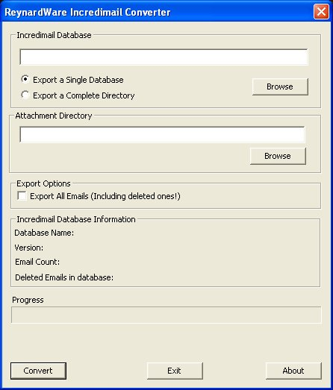Illustration 1: Reynardware Converter 0.5

Converting a Single Database
To start converting an Incredimail database, the converter needs the Attachment directory, the .imm file, the .imh (Incredimail Xe) or the containers.db (Incredimail 2) file. See below for screen shots an example of an Incredimail Xe and an Incredimail 2 export directory.
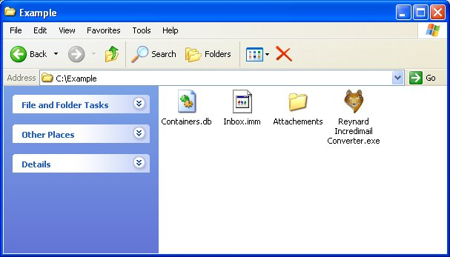Illustration 2: An Example of an Incredimail 2 export directory

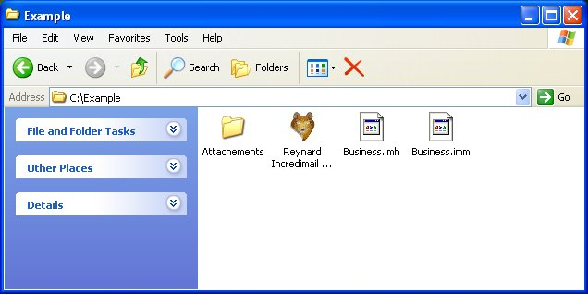Illustration 3: An example of a Incredimail Xe export directory
In the Incredimail Xe example export directory there is an attachments directory, Incredimail .imm database file called Business.imm, and an Index file called Business.imh. As mentioned in the Technical Background sections, the only difference between Incredimail Xe and Incredimail 2 are the index files. In Illustration 3, the user can see there are no .imh files but a Containers.db file for Incredimail 2.
New in version 0.52, the converter tries to find the Incredimail database and the attachments directory upon start up. If it can't find either one of them, the user will manually enter in the database or attachment directories.
To selected a single database the user can either enter the full path in the first line or click on the first “Browse” button. When the user clicks on the “Browse” button a “Open Incredimail Database File” window will open. See Illustration below.
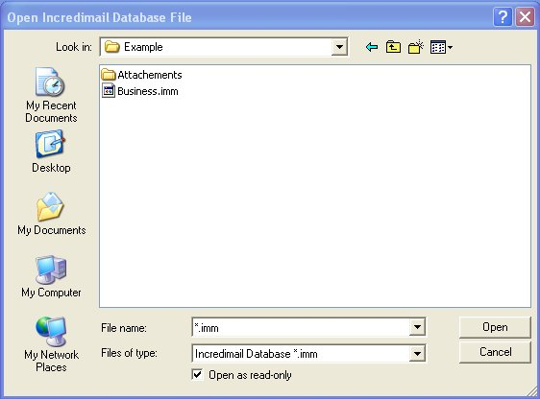Illustration 4: Open Diaglog Box of a Single Database
The user should select a .imm file or the data file. Once the user selects the data file, the converter will automatically try to open the corresponding .imh or containers.db file in the same directory. It will also display information about the version of the database in the “Incredimail Database Information” area of the converter. If the converter can not find the header or containers.db file, it will display a error message.
Once the data file is selected, the attachment directory must be selected. New in version 0.52 of the converter, it will automatically search for the attachment directory based on the location of the data file. If the converter can not find the attachment folder, the user can either enter the full path in the second line or click on the second “Browse” button to the select the Incredimail attachment directory. There is a check box to let the user have the option of exporting the marked deleted email from the database. By default the check box is not selected.
Now that the database and attachment directory is selected, the converter should look like the example below.
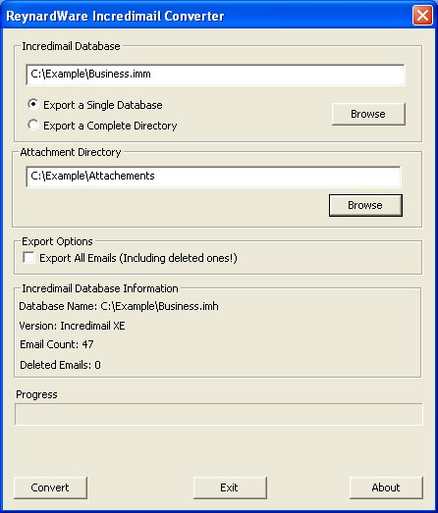Illustration 5: Reynardware Converter Before Conversion
The user can now click the “Convert” button. The progress bar will increase with each email it converts. When completed, the converter will display “Done!” (see below)
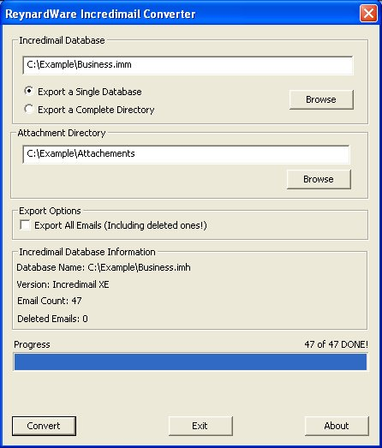Illustration 6: Reynardware Converter completed picture.

The converter will create a new folder with the same name as the data file. In this example, a new folder called “Business” was created because the user selected the “Business.imm” file. The new created directory will contain all the corresponding .eml files. It should be noted in version 0.52, when the converter successfully finds the Incredimail database in the default location, it will create the converted directories in C:\Document and Settings\<USER>\Local Settings\Application Data\IM\{some folder}\Message Box, where <USER> is the windows account login and {some folder} is a number which Incredimail is installed. Hidden directories must be shown to get to the default Incredimail database location. See below for a screen shot of a converted directory:
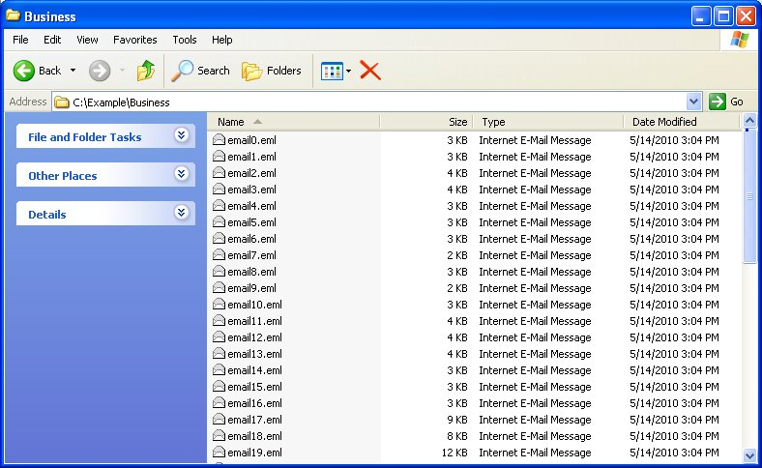Illustration 7: A completed converted directory with .eml files

Converting a Complete Directory
New in version 0.5 and later the user can now convert a complete directory instead of selecting individual database files. This option is selected by default when the converter has just been launched. Instead of just selecting a single database, the user can select a directory where all the .imm files are located. The converter will look at the same directory where the .imm files are located to find the corresponding index files or containers.db file.
When converting a complete directory, the steps are very simulator just like converting a single database. To convert a complete Incredimail directory, the user should first select the “Export a Complete Directory” radio button. By selecting this button, an extra progress bar will be displayed on the bottom. When the user selects the first “Browse” button, a dialog box will be displayed promoting the user to select the directory where all the .imm files are located.
Once the data file directory has been selected, the attachment directory must be selected as well. New in version 0.52 of the converter, it will automatically search for the attachment directory based on the location of the data folder. If the converter can not find the attachment folder, the user must either enter the full path in the second line or click on the second “Browse” button to the select the Incredimail attachment directory manually. A check box lets the user have the option of exporting the marked deleted email from the database. By default the check box is not selected.
Once the database file and attachment directory is selected, the user is ready to convert their databases. When the user clicks on the “Convert” button the converter will display the current and overall progress on converting a complete Incredimail directory. When completed the converter will create a new folders with the same name as the data file with the corresponding .eml files in them, just like the single database conversion. Again, it should be noted in version 0.52, when the converter successfully finds the Incredimail database in the default location, it will create the converted directories in C:\Document and Settings\<USER>\Local Settings\Application Data\IM\{some folder}\Message Box, where <USER> is the windows account login and {some folder} is a number which Incredimail is installed. Hidden directories must be shown to get to the default Incredimail database location.

Extra step to convert to a Thunderbird database
Once the Incredimail databases are converted to .eml files, there is one extra step to import .eml files to Mozilla's Thunderbird mbox format. The best way to import the .eml file to Thunderbird is to download “ImportExportTools” extension from the following link: http://www.nic-nac-project.de/~kaosmos/mboximport-en.html. This link has some simple instructions to import .eml files to Thunderbird.

Limitations of the ReynardWare Incredimail Converter
There is only one known limitation of the ReyardWare Incredimail Converter as of this release:
- The converter can not include Unicode attachment file names into the .eml files. For example “Дэвид.doc” This limitation is recorded as issue 7.

Acknowledgments
The Reynard Incredimail Converter icon was taken from Lothar Grimme (Carpelinx package) from http://www.iconfinder.net. This icon is licensed as GPL. The GPL text can be found in this package.
Also, a special thanks to Sebastian Rossow and Peter Mauser for helping me test and giving me some nice ideas for the converter.

Problems, Comments, or “Thanks!”
If you have any problems, comments, or a simple “Thank you!” Please email Reynardware@gmail.com

Revisions
See http://code.google.com/p/incredimail-converter-reynardware/wiki/Revisions for the latest list of the revision history.

